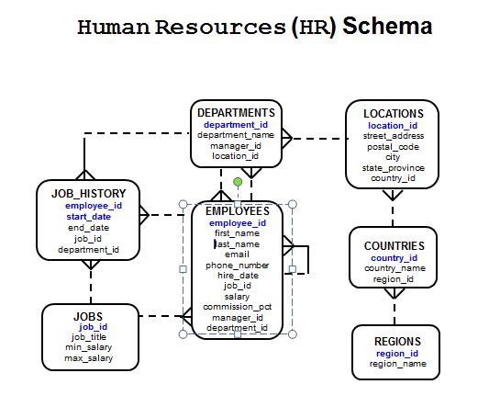**CONSULTAS 01**

*----------------------------------*

*-- 1. ESTRUCTURA DE TABLAS*

*----------------------------------*

DESC JOBS

*----------------------------------*

*-- 2. CONSULTAS SIMPLES ( TODAS LAS COLUMNAS )*

*----------------------------------*

SELECT * FROM EMPLOYEES;

*----------------------------------*

*-- 3. CONSULTA CON CAMPOS ESPECIFICOS*

*----------------------------------*

SELECT EMPLOYEE_ID, FIRST_NAME , LAST_NAME

FROM EMPLOYEES;

*----------------------------------*

*-- 4. CONSULTA CON CAMPOS CONCATENADOS*

*----------------------------------*

SELECT EMPLOYEE_ID, FIRST_NAME || ' ' || LAST_NAME "DATOS PERSONALES"

FROM EMPLOYEES;

*----------------------------------*

*-- 5. LISTA DE DATOS NO REPETIDOS ( SIN DUPLICADOS )*

*----------------------------------*

SELECT COUNTRY_ID FROM LOCATIONS;

SELECT DISTINCT COUNTRY_ID FROM LOCATIONS;

*----------------------------------*

*-- 6. CONSULTA CON CAMPOS CALCULADOS*

*----------------------------------*

SELECT LAST_NAME, SALARY SUELDO,

SALARY * 1.1 "SUELDO CON AIUMENTO"

FROM EMPLOYEES;

*---------------------------------------*

*-- 7. CONSULTA CON FILTRO CONDICIONAL*

*---------------------------------------*

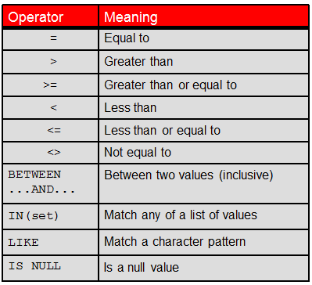

*-- 8. CUANTOS EMPLEADOS TIENEN UN SUELDO MAYOR A 2600?*

SELECT *

FROM EMPLOYEES

WHERE SALARY > 5000;

*-- 9. LISTA DE EMPLEADOS CON SALARIO MAYOR A 7000 Y MENOR A 9000*

SELECT *

FROM EMPLOYEES

WHERE SALARY > 7000 AND SALARY < 9000;

*--- 10. CLAUSULA WHERE CON CADENAS Y FECHAS*

SELECT last_name, job_id, department_id

FROM employees

WHERE last_name = 'Whalen' ;

SELECT last_name

FROM employees

WHERE hire_date = '17-FEB-96' ;

*----------------------------------*

*-- 11. BETWEEN ... AND*

*----------------------------------*

SELECT *

FROM EMPLOYEES

WHERE SALARY BETWEEN 7000 AND 9000 ;

*----------------------------------*

*--- 12. IN / NOT IN*

*----------------------------------*

SELECT *

FROM EMPLOYEES

WHERE MANAGER_ID IN ( 205 , 149);

*----------------------------------*

*-- 13. LIKE % _*

*----------------------------------*

SELECT *

FROM EMPLOYEES

WHERE JOB_ID LIKE 'SA%'

SELECT last_name

FROM employees

WHERE last_name LIKE '_o%' ;

*----------------------------------*

*-- 14. IS NULL*

*----------------------------------*

SELECT *

FROM EMPLOYEES

WHERE COMMISSION_PCT IS NULL;

*------------------------------------------------*

*-- 15. OPERADORES QUE UNEN CONDICIONES LOGICAS*

*------------------------------------------------*

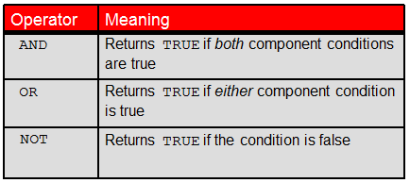

*--- 16.*

SELECT employee_id, last_name, job_id, salary

FROM employees

WHERE salary >= 10000

AND job_id LIKE '%MAN%' ;

*--- 17.*

SELECT employee_id, last_name, job_id, salary

FROM employees

WHERE salary >= 10000

OR job_id LIKE '%MAN%' ;

*--- 18.*

SELECT last_name, job_id

FROM employees

WHERE job_id

NOT IN ('IT_PROG', 'ST_CLERK', 'SA_REP') ;

*----------------------------------*

*-- 19. ORDER BY*

*----------------------------------*

SELECT LAST_NAME , FIRST_NAME, SALARY

FROM EMPLOYEES

ORDER BY LAST_NAME;

SELECT LAST_NAME , FIRST_NAME, SALARY

FROM EMPLOYEES

ORDER BY LAST_NAME, FIRST_NAME;

SELECT LAST_NAME , FIRST_NAME, SALARY

FROM EMPLOYEES

ORDER BY 2 ASC;